EMERGING METHODS FOR EARLY DETECTION OF FOREST FIRE MODEL BUILDING

PREDICTIONS

|  |  |
| --- | --- |
| Team ID | PNT2022TMID37632 |
| Project Name | Project- Emerging Methods For Early Detection of Forest Fire |

PREDICTIONS:

The last and final step is to make use of our saved model to do predictions. For that we have a class in keras called load_model. Load_model is used to load our saved model h5 file (alert.h5).

**IMPORT LIBRARIES:**

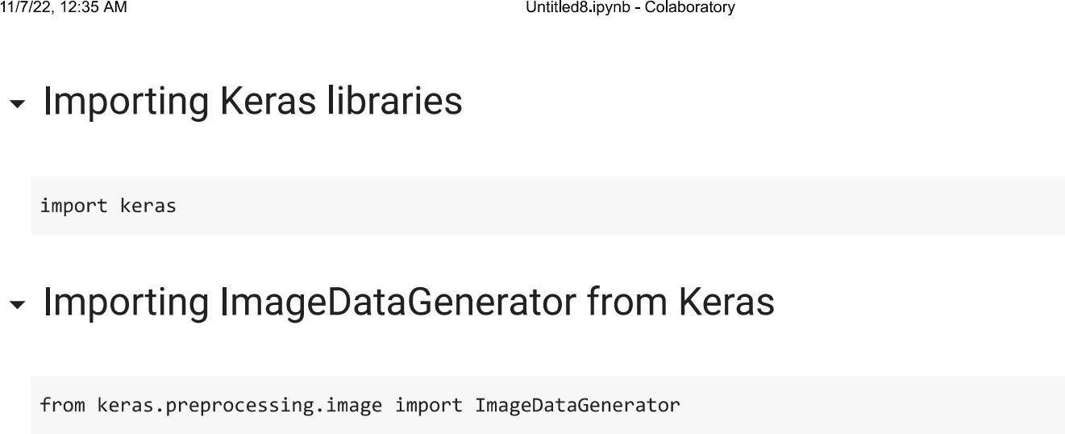

**IMPORT ImageDataGenerator FROM KERAS:**

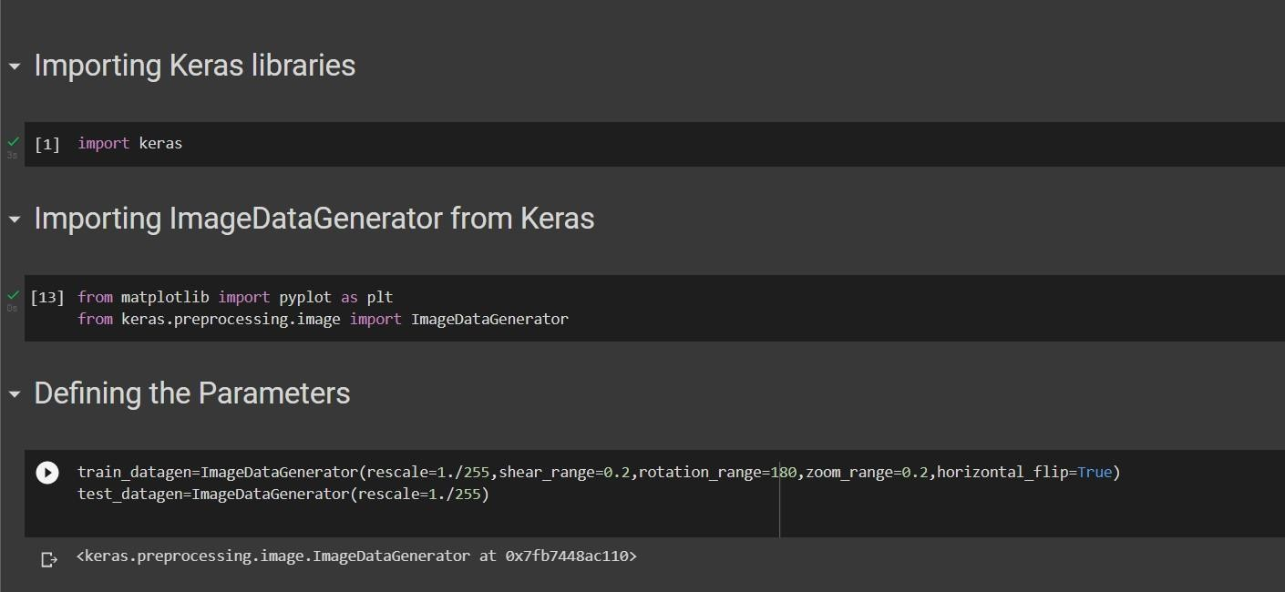

APPLYING ImageDataGenerator to train dataset:

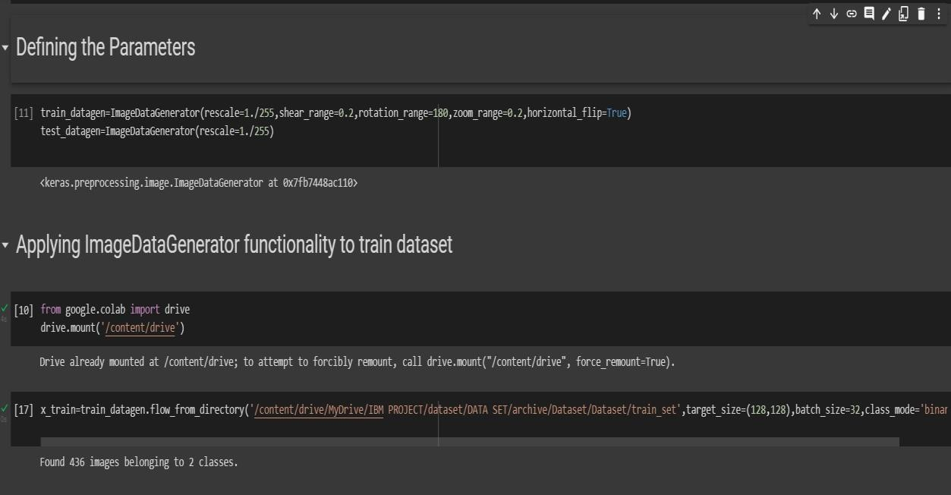ply**flow_from_directory ( )**methodfor Train folder.

APPLYING ImageDataGenerator to test dataset:

Applying the **flow_from_directory ( )** methodfortest folder.

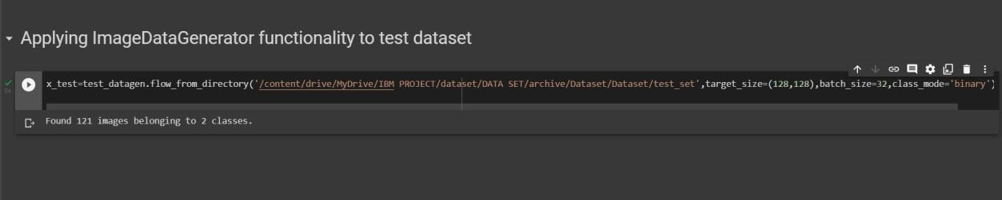

IMPORTING MODEL BUILDING LIBRARIES:

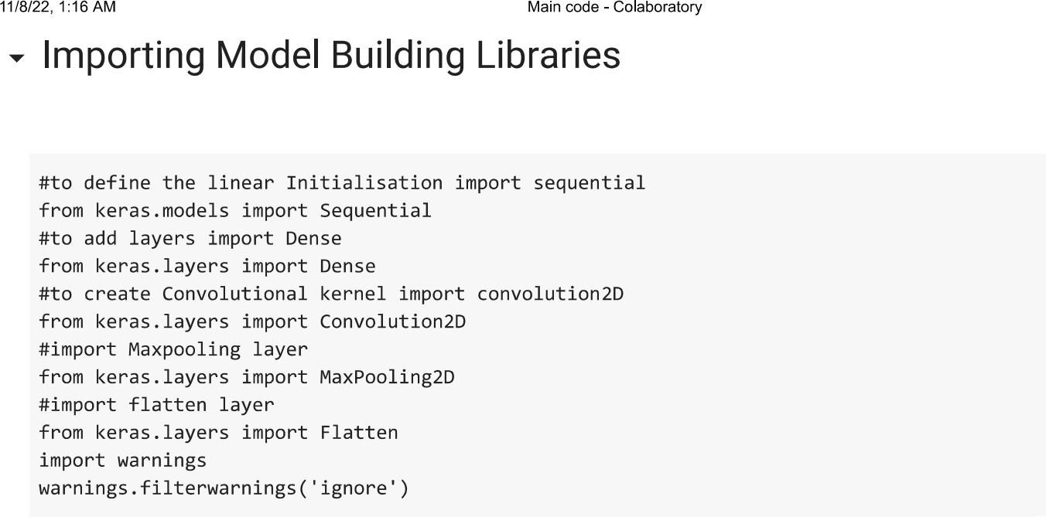

**INITIALIZING THE MODEL:**

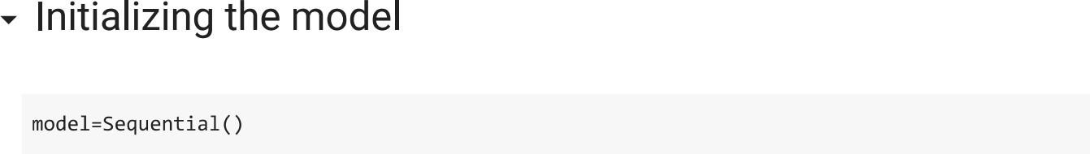

**ADDING CNN LAYERS:**

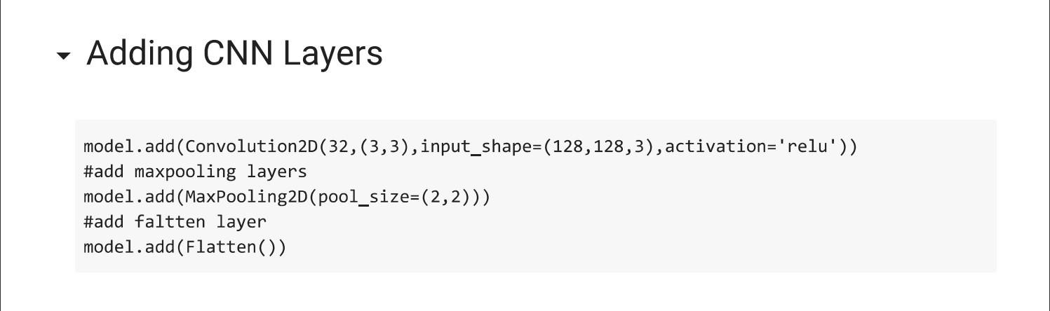

**ADDING DENSE LAYERS:**

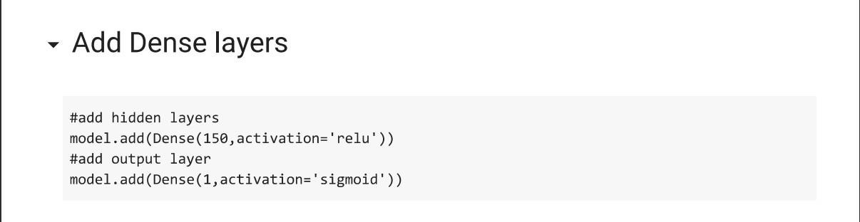

**CONFIGURING THE LEARNING PROCESS:**

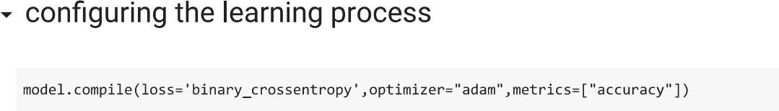

**TRAINING THE MODEL:**

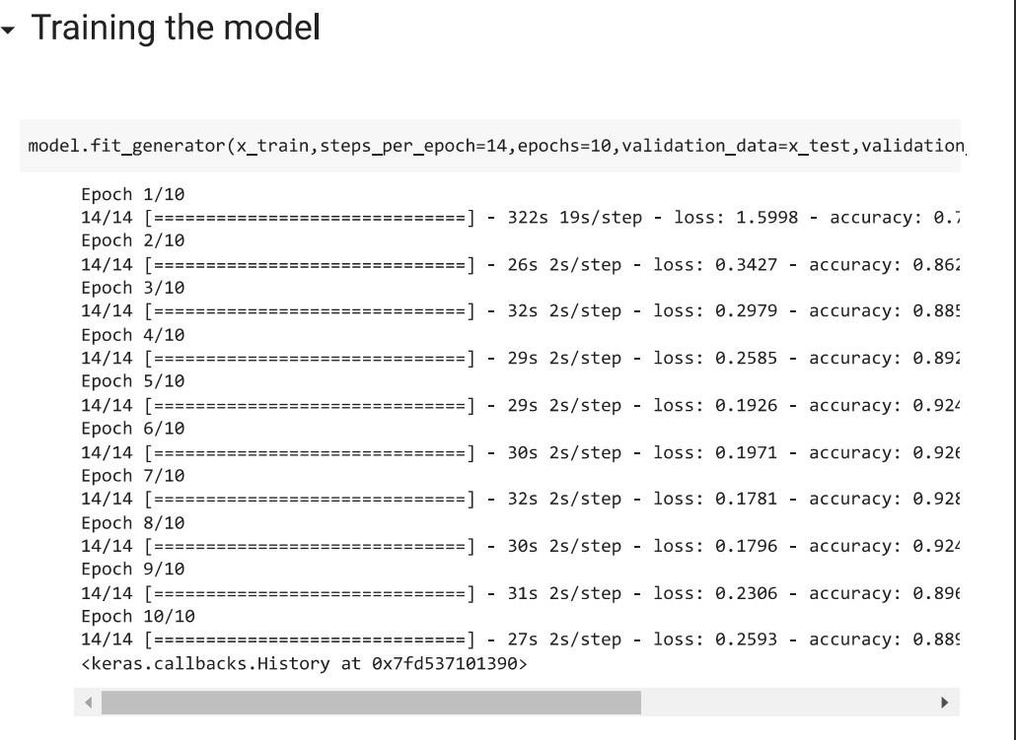

**SAVE THE MODEL:**

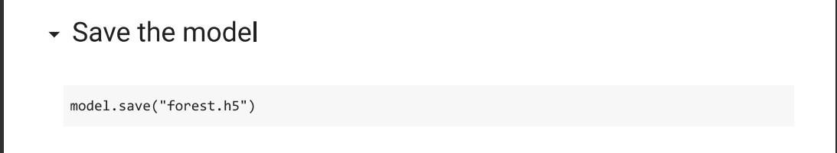

**PREDICTIONS:**

